2016 Marriage Retreat & Enrichment Seminar Hosted by
The Church of Christ in Highland Heights

Please print all information very clearly for verification purposes.

This form is to be completed only once and should accompany your non-refundable
registration fee of $25.

First and Last Name (Husband):
First and Last Name (Wife):
Address:
City: ___________________________ State: _________ ZIP: ______________
Home Phone Number: ___________________________________
Cell Phone Number(s): (His) ___________________ (Hers)__________________
E-mail: ______________________________________________________________
Congregation: ________________________________________________________ (Name) (City)
If you or your spouse attends a different congregation than the one above, please list it below.
Congregation: ________________________________________________________ (Name) (City)
Check one: ___Check ___Cash (Please do not send cash through the mail.)

The HHCOC Marriage Retreat and Enrichment Seminar is designed to minister to couples that are married according to biblical and scriptural teachings as stated in Matthew 19:4-6:

4 And he answered and said unto them, Have ye not read, that he which made them at the beginning made them male and female, 5 And said, For this cause shall a man leave father and mother, and shall cleave to his wife: and they twain shall be one flesh? 6 Wherefore they are no more twain, but one flesh. What therefore God hath joined together, let not man put asunder.”

Make checks payable to: Highland Heights Church of Christ
Mail payments to: Highland Heights COC Marriage Retreat
Attn: Horace Stroud
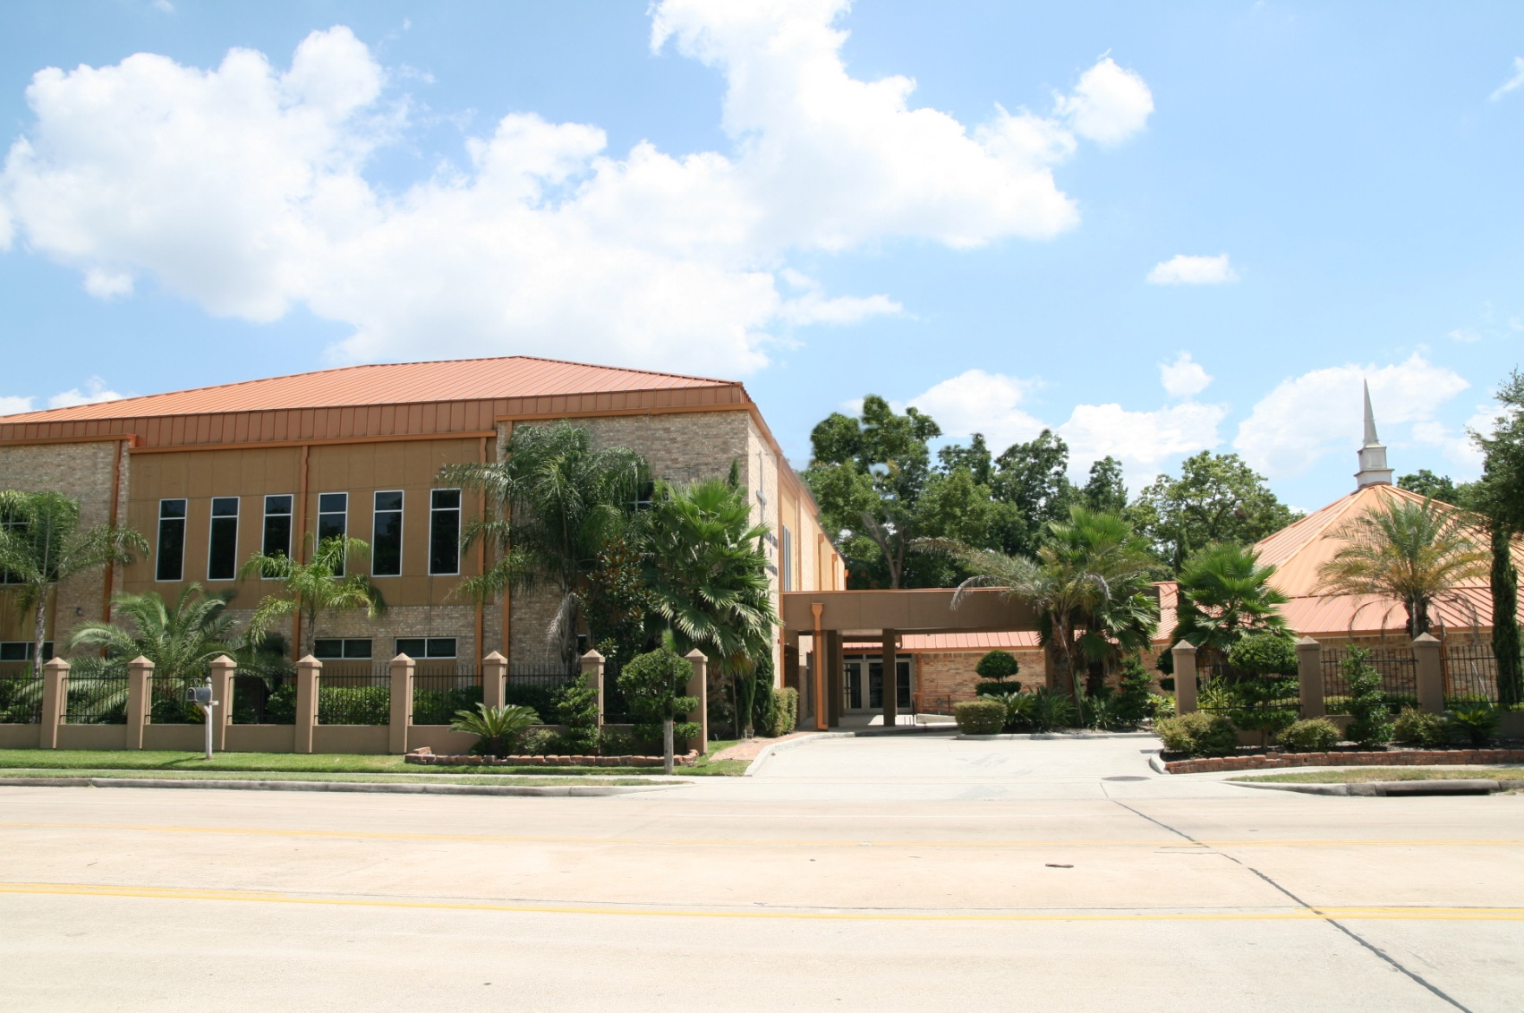
P.O. Box 38659
Houston, TX 77238

